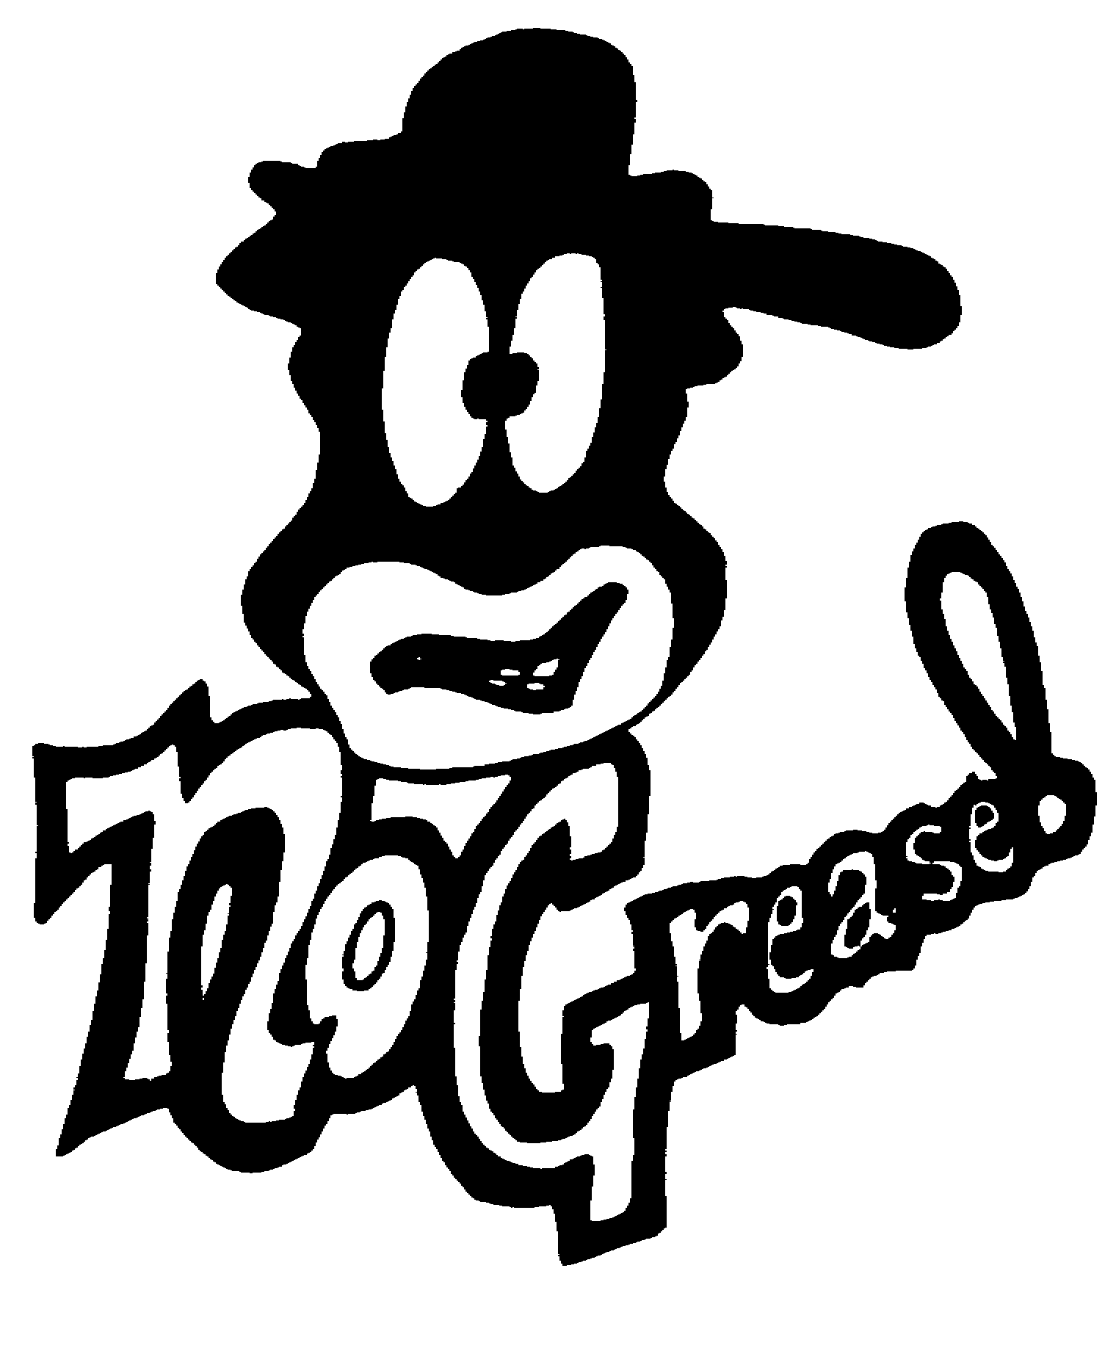

No Grease Barber School
3731 North Sharon Amity Road
Charlotte North Carolina 28205

BARBER SCHOOL APPLICATION
Personal Information
Full name (First, Last, Middle): ___________________________________________________________

Home Address: _______________________________________________________________________

City, State, Zip: _______________________________________________________________________

Telephone: Primary (_______) _________________________ Secondary (_______) ________________________

Email Address: _______________________________________________________________________

Social Security Number#: _____________-____________-____________

Date of Birth: ______/______ /_______

Gender: ▢ Male ▢ Female
Marital Status: ▢ Single ▢ Married ▢ Divorced
Are you a veteran? ▢ Yes ▢ No If yes service #
Are you employed? ▢ Yes ▢ No Place of Employment
Work Shift(s) ___________________________________________________

Please list any physical disabilities No Grease Barber School should be aware of:
_____________________________________________________________________________________________

Admission Information
Highest level of education completed ▢ High School Graduate ▢ GED Certificate
Name of High School or Program
Month/Year of Completion
Desired start date to begin school:

Desired program schedule:
▢ F/T Morning: Tuesday – Friday 9 a.m. – 5 p.m. & Saturday 9 a.m. – 1 p.m.
▢ P/T Day: Tuesday – Friday 9 a.m. – 1 p.m. & Saturday 9 a.m. – 1 p.m.

Page 1 of 2
Revised Last: 09/2018

Have you attended barber school previously? ▢ Yes ▢ No ▢ Hours transferring ___
Hours must be approved, recognized, accepted by NO GREASE Barber School and the NC Barber Board before acceptance into school and before signing the NO GREASE Enrollment Agreement.
Have you ever been found guilty or convicted of a felony? ▢ Yes ▢ No ▢ Pending Felony Charge(s)
If yes, please explain the nature of the crime(s), the county (ies) and state(s) in which the crime(s) occurred.
_______________________________________________________________________________________________________________________________________________________________________________________________________________________________________________________________________________________

Have you ever been convicted of a sexual offense? ▢ Yes ▢ No ▢ Pending Sexual Charge(s)

How did you hear about No Grease Barber School?

Emergency Contacts
Name ______________________________________________________________________________________

Relationship ___________________________________________________________________________________

Full Address ___________________________________________________________________________________

Phone Number _____________________________ E-mail _____________________________________________

Name ______________________________________________________________________________________

Relationship ___________________________________________________________________________________

Full Address ___________________________________________________________________________________

Phone Number _____________________________ E-mail _____________________________________________

I certify the information that I have given is true and correct. I have also received or had access to all pre-enrollment
information regarding NO GREASE Barber School’s outcome rates (prior to enrollment) for the students in the school, compensation a successful graduate may expect, the physical demands and safety requirements for the profession of barbering, state licensing requirements, orientation and a copy of the school catalog.

_____________________________________________________________________________________________
Signature of Applicant Date

_____________________________________________________________________________________________
Signature of Parent or Guardian (if applicant is under 18) Date

Page 2 of 2
Revised Last: 04/2017

No Grease Barber School
Student Applicant Acknowledgement

93B-8.1. Use of criminal history records.
(a) The following definitions apply in this section:
(1) Applicant. - A person who makes application for licensure from an occupational licensing board.
(2) Board. - An occupational licensing board as defined in G.S. 93B-1.
(3) Criminal history record. - A State or federal history of conviction of a crime, whether a misdemeanor or felony, that bears upon an applicant's or a licensee's fitness to be licensed or disciplined.
(4) Licensee. - A person who has obtained a license to engage in or represent himself or herself to be a member of a particular profession or occupation.
(b) Unless the law governing a particular occupational licensing board provides otherwise, a board shall not automatically deny licensure on the basis of an applicant's criminal history. If the board is authorized to deny a license to an applicant on the basis of conviction of any crime or for commission of a crime involving fraud or moral turpitude, and the applicant's verified criminal history record reveals one or more convictions of any crime, the board may deny the license if it finds that denial is warranted after consideration of the following factors:
(1) The level and seriousness of the crime.
(2) The date of the crime.
(3) The age of the person at the time of the crime.
(4) The circumstances surrounding the commission of the crime, if known.
(5) The nexus between the criminal conduct and the prospective duties of the applicant as a licensee.
(6) The prison, jail, probation, parole, rehabilitation, and employment records of the applicant since the date the crime was committed.
(7) The subsequent commission of a crime by the applicant.
(8) Any affidavits or other written documents, including character references.
(c) The board may deny licensure to an applicant who refuses to consent to a criminal history record check or use of fingerprints or other identifying information required by the State or National Repositories of Criminal Histories.
(d) This section does not apply to The North Carolina Criminal Justice Education and Training Standards Commission and the North Carolina Sheriffs' Education and Training Standards Commission. (2013-24, s. 1.)

§ 86A-18. Disqualifications for certificate.
The Board may either refuse to issue or to renew, or may suspend or revoke any certificate of registration or barbershop permit or barber school permit for any one or combination of the following causes:
(1) Conviction of the applicant or certificate holder of a felony proved by certified copy of the record of the court conviction;
(2) Gross malpractice or gross incompetence;
(3) Continued practice by a person knowingly having an infectious or contagious disease after being warned in writing by the Board to cease practice;
(4) Habitual drunkenness or habitual addiction to the use of morphine, cocaine or other habit forming drugs;
(5) The commission of any of the offenses described in subdivisions (3), (5), and (6) of G.S. 86A-20;
(6) The violation of any one or more of the sanitary rules and regulations established by statute or rule or regulation of the Board, provided that the Board has previously given two written warnings to the individual committing the violation;
(7) The violation of the rules and regulations pertaining to barber schools, provided that the Board has previously given two written warnings to the school. (1929, c. 119, s. 19; 1941, c. 375, s. 8; 1945, c. 830, s. 6; 1961, c. 477, s. 4; 1979, c. 695, s. 1; 1981, c. 457, s. 9.)

I acknowledge that I have been provided and read the board’s statutes regarding criminal convictions.

_____________________________________________________________________________________
Applicant/Student signature Date

